**Internship Report**   
 **on**   
**Web-Based File and Link Management System Submitted in partial fulfillment of the requirements**  **for the award of the degree of**   
 **Bachelor of Technology**

**in**

**Computer Science & Engineering**

|  |  |
| --- | --- |
| **Submitted To:**  Ms. Sheetal   Assistant Professor | **Submitted By:**  Anuj Rawat   211302063 |

B.Tech CSE(GEN) 8th Sem   
 2021-2025



**DEPARTMENT OF COMPUTER SCIENCE AND ENGINEERING**

**FACULTY OF ENGINEERING AND TECHNOLOGY**

**SGT UNIVERSITY, GURUGRAM**

**April 2025**

**Chapter 1: Introduction to Organization**

Codec Technologies India stands as a dynamic force in the global technology landscape, committed to empowering learners and bridging the gap between talent and opportunity. As a part of its mission, the company has built a robust platform that not only nurtures individual growth but also fosters international collaboration and innovation across industries.

Operating across more than 27 countries, Codec Technologies India delivers dedicated IT and business consultancy services with a focus on driving strategic growth and technological transformation. Its commitment to excellence and innovation positions Codec Technologies as a trusted partner for organizations seeking to harness technology to achieve their business objectives.

At its core, Codec Technologies is driven by a deep passion for education, skill development, and professional excellence. The organization creates meaningful career opportunities for aspiring professionals through immersive programs such as internships, project-based learning, and professional certifications. By offering hands-on experiences that replicate real-world challenges, Codec Technologies ensures that learners acquire industry-relevant skills and are well-prepared to contribute effectively to the global workforce.

Codec Technologies’ operations are anchored at the Chandivali IT Hub in Mumbai, India, providing a strategic advantage in tapping into one of the country’s most vibrant technological ecosystems. The company operates with a hybrid work model, enabling flexibility and accessibility for a diverse talent pool across India and beyond.

Under the leadership of industry experts like Dr. Anurag Shrivastava, Talent Acquisition Manager, Codec Technologies India has developed a reputation for nurturing innovation, valuing meritocracy, and rewarding excellence. Their initiatives, including performance-based scholarships and global exposure, reflect their deep-rooted commitment to recognizing and supporting outstanding talent.

With a vision to create a globally connected and empowered workforce, Codec Technologies continues to be a beacon for aspiring developers, consultants, and technology leaders. Its emphasis on continuous learning, innovation, and global connectivity makes it a standout organization in the ever-evolving digital world.

**Chapter 2: Project Description**

**2.1 Introduction**

In the rapidly evolving digital landscape, the need for organized, secure, and efficient management of files and external links has become critical for individuals and organizations alike. To address this need, the Web-Based File and Link Management System has been designed and developed. This   
comprehensive platform offers users a centralized solution to upload, preview, manage, and distribute digital resources seamlessly through a web interface.

The system not only provides basic file storage capabilities but also integrates advanced features such as real-time file previews, QR code generation for links, and streamlined downloading options, enhancing overall accessibility and usability.

**2.2 Core Functionalities**

The system is engineered to deliver a range of functionalities that ensure an intuitive and productive user experience:

File Upload and Instant Preview:   
Users can upload various types of files, including images, PDF documents, source code files, and more. Upon upload, the system automatically generates a preview of the file, allowing users to quickly verify the content without needing to download or open it separately.

Link Submission and Management with Validation:   
External links can be added to the system through a user-friendly submission form. The platform incorporates validation mechanisms to ensure that only properly formatted and functional links are stored, thus maintaining the quality and reliability of the resources.

QR Code Generation for Links:   
To facilitate easy mobile access, the system automatically generates a unique QR code for each external link. Users can scan the QR codes using smartphones and other devices, promoting instant and convenient connectivity.

Simplified File and Link Access:   
Files can be downloaded with a single click, and link URLs can be copied directly to the clipboard with ease. This feature eliminates unnecessary steps and enhances workflow efficiency.

**2.3 Technical Overview**

The system leverages modern web technologies to provide a robust and scalable solution:

**Frontend Development:**   
The user interface is crafted using HTML5 and CSS3, ensuring responsiveness across various devices and screen sizes. The design principles focus on clarity, simplicity, and ease of navigation to deliver an optimal user experience.

**Backend Development:**   
The backend is built with Python Flask, a lightweight yet powerful web framework. Flask facilitates dynamic content rendering, secure file storage, database management, and seamless processing of user inputs.

**Security and Validation:**   
Security features, including validation of uploaded files and submitted links, are integrated into the system to safeguard against malicious inputs and ensure data integrity.

**2.4 Benefits and Advantages**

By implementing the Web-Based File and Link Management System, users gain several advantages:

Centralized management of digital assets.

Instant file previews without the need for external applications.

Mobile-accessible links through QR code scanning.

Time-saving download and copy features.

A secure and responsive platform capable of scaling with user demands.

**Chapter 3: Objective and Scope of the Project**

**3.1 Objectives of the Project**

The primary objective of the **Web-Based File and Link Management System** is to provide an organized, secure, and highly efficient platform for managing digital resources, encompassing both file uploads and external link submissions. The system is designed to address the increasing demands for centralized digital content management and to streamline workflows through automation, validation, and user-centric features.

The key objectives of the project are outlined as follows:

•**Efficient Digital Resource Management:**   
To enable users to seamlessly upload, categorize, preview, and manage a wide variety of digital files and external links within a centralized and intuitive platform.

•**Interactive File Preview:**   
To integrate real-time preview capabilities that allow users to instantly view uploaded files such as images, PDFs, and code files without the need for external software or downloads, thus enhancing operational efficiency.

•**Secure Access Control and Data Integrity:**   
To ensure the security and integrity of the system by validating all uploaded files and submitted links, thus protecting against malicious inputs and maintaining the authenticity of the stored resources.

•**QR Code Integration for Enhanced Accessibility:**   
To generate unique QR codes automatically for each submitted link, promoting mobile-friendly access and broadening the usability of resources across multiple devices and platforms.

•**Responsive and Intuitive User Interface:**   
To design a responsive, aesthetically pleasing, and easy-to-navigate interface that adapts to various screen sizes and devices, ensuring a consistent user experience across desktops, tablets, and smartphones.

•**Scalable and Modular Architecture:**   
To develop the system with a scalable architecture that allows for future enhancements, additional feature integrations, and the accommodation of a growing user base without performance degradation.

**3.2 Scope of the Project**

The scope of the **Web-Based File and Link Management System** encompasses the full development and deployment of a functional web application that addresses the needs outlined in the project objectives. The system is designed to be flexible, user-friendly, and adaptable to a variety of use cases across different industries, educational institutions, and personal use scenarios.

The scope includes, but is not limited to, the following aspects:

•**User Operations:**   
 oUpload files of various formats such as images (JPEG, PNG), documents (PDF, DOCX), and code files (TXT, PY, HTML, etc.). oSubmit and manage external links through a simple web form with built-in validation.

oPreview uploaded files instantly in the web interface without requiring downloads.

oDownload files and copy link codes easily with a single-click functionality.

•**System Functionalities:**   
 oAutomated QR code generation for each external link, allowing for easy mobile access.

oValidation mechanisms to ensure the quality and safety of both uploaded files and submitted URLs.

oReal-time feedback and alerts for successful uploads, invalid submissions, and other user actions.

oStorage and retrieval functionalities for all uploaded resources.

•**Technical Implementation:**   
 oFrontend developed using **HTML5** and **CSS3** for responsive design and seamless user interaction.

oBackend powered by **Python Flask**, providing dynamic content rendering, secure data handling, and scalable server-side operations. oIncorporation of database systems (e.g., SQLite, PostgreSQL) for resource management.

oImplementation of basic security features like file type checking, link validation, and user authentication (optional in extended versions).

•**Deployment and Maintenance:**   
 oThe system is intended for deployment on web servers, accessible via standard browsers.

oDesigned with a modular structure for ease of maintenance, upgrades, and feature expansions.

oScalability considerations to ensure that the system can handle an increasing number of users and data without major architectural changes.

•**Limitations (Current Scope):**   
 oThe initial version focuses on core file and link management features without advanced collaboration tools (e.g., multi-user access control, versioning, etc.).

oIntegration with cloud storage platforms or enterprise Single Sign-On (SSO) systems is outside the scope of the current project phase but can be considered for future development.

**Chapter 4: Methodology and Tools Used**

**4.1 Introduction**

The development of the **Web-Based File and Link Management System** followed a structured yet flexible methodology that emphasized iterative development, early feedback, and modular design. By integrating agile practices with a modular development strategy, the project ensured adaptability to changes, continuous improvement, and a clear division of work for better manageability.

This chapter discusses the project’s methodology in detail and highlights the various tools, technologies, and strategies employed throughout the development lifecycle.

**4.2 Development Methodology**

**4.2.1 Agile Practices**

The project adopted key principles of the **Agile Development Methodology** to

maintain flexibility and accommodate evolving requirements. Agile practices,

including iterative progress evaluations, frequent testing, and continuous

feedback loops, allowed the development process to remain dynamic and

responsive to improvements.

**Key characteristics of the agile approach used:**

•**Iterative Development:** New features were built in small increments and tested immediately after implementation.

•**Continuous Feedback:** Regular reviews of implemented modules to identify improvements early.

•**Adaptive Planning:** Adjustments made as per evolving project needs and findings during testing phases.

**4.2.2 Modular Development Approach**

To manage complexity and enhance maintainability, the project was developed

in a **modular** fashion, where functionalities were divided into independent

components. This approach made the codebase easier to understand, test, debug,

and upgrade.

**Modules included:**

•File Upload and Management

•External Link Submission and QR Code Generation •Instant File Preview   
•Secure Download and Copy Functions

Each module was developed, tested, and refined separately before integrating into

the final system.

**4.3 Tools and Technologies Used**

A range of modern and efficient tools and technologies were employed to build

the system, ensuring a robust, scalable, and user-friendly product.

|  |  |  |  |
| --- | --- | --- | --- |
| ***Area*** | ***Tools*** | ***and*** | ***Purpose*** |

***Technologies***

|  |  |  |  |  |  |  |  |  |  |  |  |  |  |  |  |  |  |  |
| --- | --- | --- | --- | --- | --- | --- | --- | --- | --- | --- | --- | --- | --- | --- | --- | --- | --- | --- |
| *Frontend*  *Development Backend*  *Development*  *Libraries*  *Storage*  *Management*  *Security*  *Measures*  *Testing*  *and Deployment* | |  |  | | --- | --- | | HTML5, CSS3 | Designing a responsive and interactive user |  |  |  |  |  | | --- | --- | --- | --- | | Python | with | Flask | interface. | | Managing server-side operations, dynamic | | Framework | | content rendering, and handling file and link |   operations.   |  | | --- | | Highlight.js, pyqrcode Syntax highlighting for code previews and QR |  |  |  | | --- | --- | | Local Directories with Metadata | code generation for external links.  Storing uploaded files and maintaining metadata (such as upload time, file type, etc.) for |   organized retrieval.   |  |  | | --- | --- | | Basic Authentication | Ensuring only authorized users can access |  |  |  | | --- | --- | | Manual Testing and Cloud Deployment | sensitive functionalities.  Ensuring system functionality through manual test cases and hosting the system on cloud |   servers for broader accessibility. |

**4.4 Implementation Strategy**

The implementation of the system was carried out in a sequential yet flexible

manner, ensuring a logical and efficient development flow. The major phases

included:

•**Requirement**  **Analysis:**  A thorough analysis of user needs and system requirements was conducted to define project objectives, features, and technical constraints.

•**System**  **Design:**  Based on the requirements, the system architecture was designed, including database schema, user interface layout, and backend flow.

•**Development:**   
The actual coding process where frontend components, backend APIs, file storage logic, and link management features were implemented.

•**Testing:**   
Extensive manual testing was conducted to validate individual modules and the complete integrated system. Tests included functionality checks, file validation, link validation, security testing, and user interface responsiveness across devices.

•**Deployment:**   
Post successful testing, the system was deployed on a cloud environment to ensure accessibility, scalability, and real-world usability.

**4.5 Flow Diagram of the Project**

Below is a conceptual flow diagram that outlines the operational logic of the

Web-Based File and Link Management System:

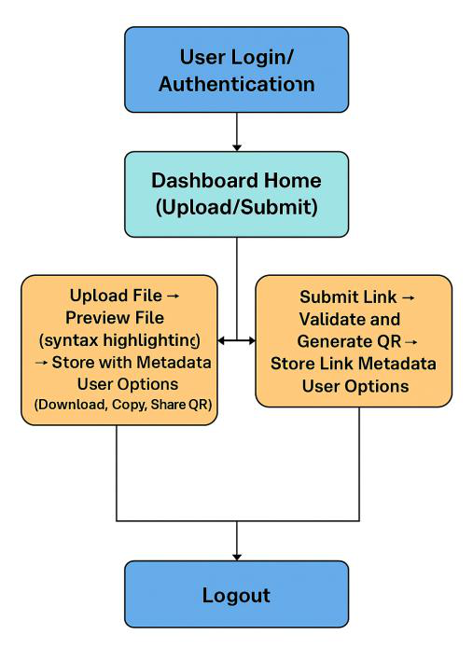

**Figure 1. Flow Chart**

This flow ensures smooth and logical transitions between different system

functionalities, maximizing user efficiency and experience.

**Chapter 5: Progress Report 5.1 Introduction**

The development of the **Web-Based File and Link Management System** was systematically organized and executed over a period of eight weeks. Each week was carefully planned to focus on specific milestones, ensuring smooth and structured progress. This chapter presents a detailed report of the week-by-week development activities, highlighting major achievements, challenges addressed, and outcomes accomplished during the project timeline.

5.2 Weekly Progress Overview

**Week 1: Requirements Gathering and System Design Finalization**

The first week was dedicated to laying a solid foundation for the project through extensive requirements gathering and system design planning. Key activities included:

•Identifying functional and non-functional requirements. •Outlining user stories and use cases.

|  |  |  |  |  |  |
| --- | --- | --- | --- | --- | --- |
| •Finalizing | the | system | architecture, | including | frontend-backend |

communication.

•Designing initial database schema for file and link metadata storage.

•Preparing wireframes and layout sketches for the user interface.

**Outcome:**   
A clear project roadmap and system blueprint were established, providing direction for subsequent development phases.

**Week 2: Environment Setup and Basic Framework Initialization**

In the second week, the technical groundwork was laid for development:

•Setting up the development environment with necessary installations (Python, Flask, HTML5, CSS3 tools).

•Initializing the Flask server to handle HTTP requests and responses. •Creating basic HTML templates for the frontend layout (home page, upload page, links page).

**Outcome:**

The project environment was ready for development, and the base framework

for frontend and backend interaction was established.

**Week 3: Implementation of File Upload and Preview Functionality**

The third week marked the development of core file management

functionalities:

•Implementation of file upload modules with validation checks for allowed file types.

•Creation of file storage system using local directories with organized subfolders.

•Enabling instant preview for uploaded files (images, PDFs, code files) within the web interface.

**Outcome:**

Users could upload files and view real-time previews directly from the system,

enhancing usability.

**Week 4: Development of Link Submission and QR Code Generation**

Week four focused on link management and QR code integration:

•Designing and implementing a user-friendly link submission form. •Incorporating validation mechanisms to verify the proper formatting and functionality of submitted links.

•Using the **pyqrcode** library to automatically generate QR codes for each valid external link.

•Displaying generated QR codes alongside the corresponding links in the user dashboard.

**Outcome:**

The system successfully allowed users to submit links and access them via auto-

generated QR codes, enhancing mobile accessibility.

**Week 5: Authentication Module and Security Testing**

In the fifth week, initial security measures were incorporated to protect the

system:

•Developing a basic authentication module to restrict unauthorized access to key functionalities.

•Conducting preliminary security tests to identify vulnerabilities in file upload and link submission processes.

•Implementing basic session management features.

**Outcome:**

An initial layer of security was established, safeguarding user data and system

operations against unauthorized access.

**Week 6: Creation of Metadata Management System**

Week six was dedicated to enhancing the organization and retrieval of uploaded

content:

•Designing a lightweight metadata management system to store essential details (filename, file type, upload date, link URL, QR code path) for all uploaded files and links.

•Integrating the metadata system with the backend to enable easy querying, filtering, and display.

**Outcome:**

A structured approach to file and link management was achieved, improving the

overall system organization and user experience.

**Week 7: Manual Testing and Mobile Responsiveness Testing**

Testing and user experience enhancement were the focus areas during the

seventh week:

•Conducting thorough manual testing across all functionalities including file upload, link submission, QR code generation, file previews, and authentication.

•Identifying and fixing bugs discovered during testing phases.

•Ensuring the system’s frontend design was fully responsive across different devices (desktops, tablets, smartphones) using HTML5 and CSS3 media queries.

**Outcome:**

System stability was significantly improved, and mobile responsiveness was

validated, ensuring a seamless experience for all users.

**Week 8: Final Deployment and Project Documentation**

The final week focused on project closure activities:

•Preparing the system for live deployment on a cloud server.

•Conducting final end-to-end testing post-deployment to verify real-world functionality.

•Compiling detailed project documentation covering system design, user manual, and developer notes.

•Creating final project reports and summarizing achievements.

**Outcome:**

The project was successfully deployed and documented, making it ready for presentation, usage, or further enhancements.

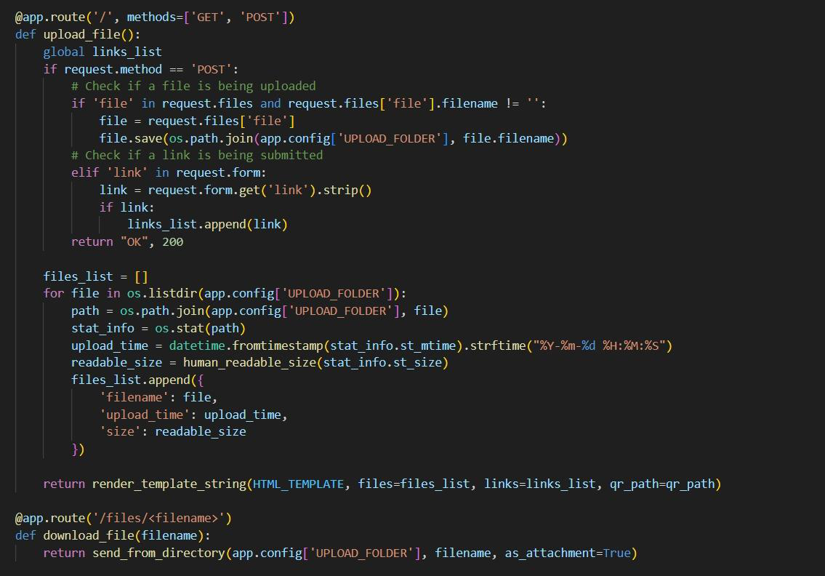

**Chapter 6: Expected Outcomes and Benefits**

**6.1 Introduction**

The development and deployment of the **Web-Based File and Link Management System** are expected to result in significant technical, functional, and educational outcomes. These outcomes not only address the core objectives of the project but also lay the groundwork for future scalability and innovation. Furthermore, the process has contributed meaningfully to personal skill development and a deeper understanding of end-to-end software project management.

This chapter discusses the expected deliverables of the system and the personal and professional growth achieved through the project lifecycle.

**6.2 Expected Outcomes**

**6.2.1 Efficient File and Link Management**

The primary outcome of the project is the establishment of a streamlined, centralized system for uploading, previewing, storing, and managing digital files and external links. Users can now:

•Easily upload and organize files of various formats.

•Submit and manage links efficiently with automated validation.

•Search, retrieve, and interact with stored resources quickly and reliably. •Maintain a secure repository with metadata tracking for future references.

This improves the management of digital resources significantly, reducing time and effort in handling scattered data manually.

**6.2.2 Enhanced Sharing Capabilities**

By incorporating features like QR code generation and single-click link copying, the system greatly enhances the ease of sharing resources. Users can:

•Access links instantly via mobile devices by scanning QR codes.

•Copy download links or external URLs efficiently for distribution across different platforms.

•Improve collaboration and content dissemination in educational, organizational, and personal contexts.

This functionality aligns with modern digital sharing trends and enhances user convenience.

**6.2.3 Responsive and Secure Application**

The system has been designed with responsiveness and security at its core:

•**Responsive Design:** The HTML5 and CSS3-based frontend ensures that the application provides a consistent and optimized user experience across devices including desktops, tablets, and smartphones.

•**Basic Security Measures:** Implementation of file validation, URL checks, and authentication mechanisms strengthens system reliability and protects user data from malicious threats.

These features contribute towards building user trust and encouraging widespread adoption of the application.

**6.2.4 Foundation for Future Enhancements**

While the current system meets its initial objectives, it has been designed with scalability and extensibility in mind. Potential future enhancements include:

•Multi-user access and role-based permissions.

•Integration with cloud storage solutions like Google Drive or AWS S3. •Advanced search functionalities with file categorization and filtering. •Incorporation of encryption for file uploads and link protection.

By designing a modular and extensible backend using Python Flask, the system can evolve and expand without significant re-engineering efforts.

**6.3 Personal Benefits**

Beyond the technical achievements, this project has served as a valuable learning experience, fostering both professional and personal growth in several key areas:

**6.3.1 Skill Development**

The project offered extensive hands-on exposure to modern web development technologies and methodologies, including:

•Proficiency in **Python Flask** backend development.

•Frontend design using **HTML5** and **CSS3** for responsive layouts.

•Practical application of third-party libraries like **Highlight.js** and **pyqrcode**.

It enhanced technical versatility and reinforced full-stack development skills.

**6.3.2 Understanding of Project Life Cycle**   
Through this project, a thorough understanding of the complete software development life cycle (SDLC) was gained, covering:

•Requirement analysis and specification.

•System design and architecture planning.

•Incremental development and iterative testing.

•Final deployment and post-deployment documentation.

This end-to-end project management experience provided insights into real-world software development practices and agile methodologies.

**6.3.3 Improved Technical and Problem-Solving Skills**   
The challenges encountered during system design, debugging, and testing phases significantly strengthened technical acumen and problem-solving capabilities.

Key areas of improvement included:

•Identifying and resolving integration issues between frontend and backend. •Implementing secure and efficient file handling mechanisms.

•Optimizing user interface responsiveness and accessibility.

•Enhancing system stability through extensive manual testing.

Such experiences have contributed to building a proactive mindset towards troubleshooting and technical decision-making.

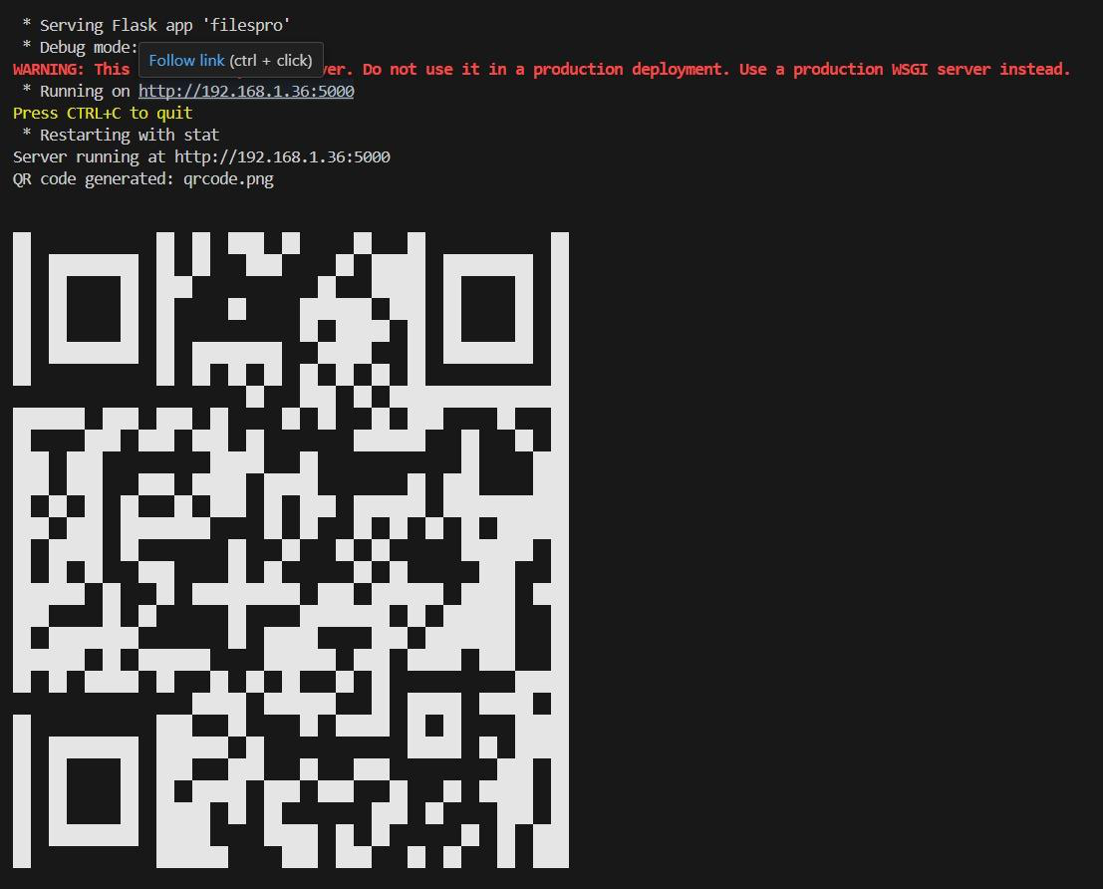

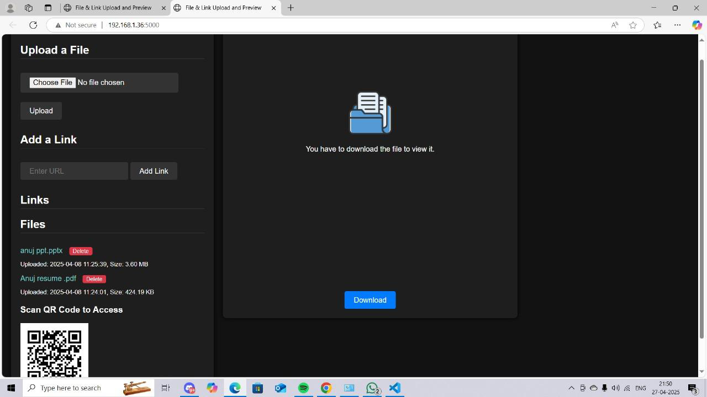

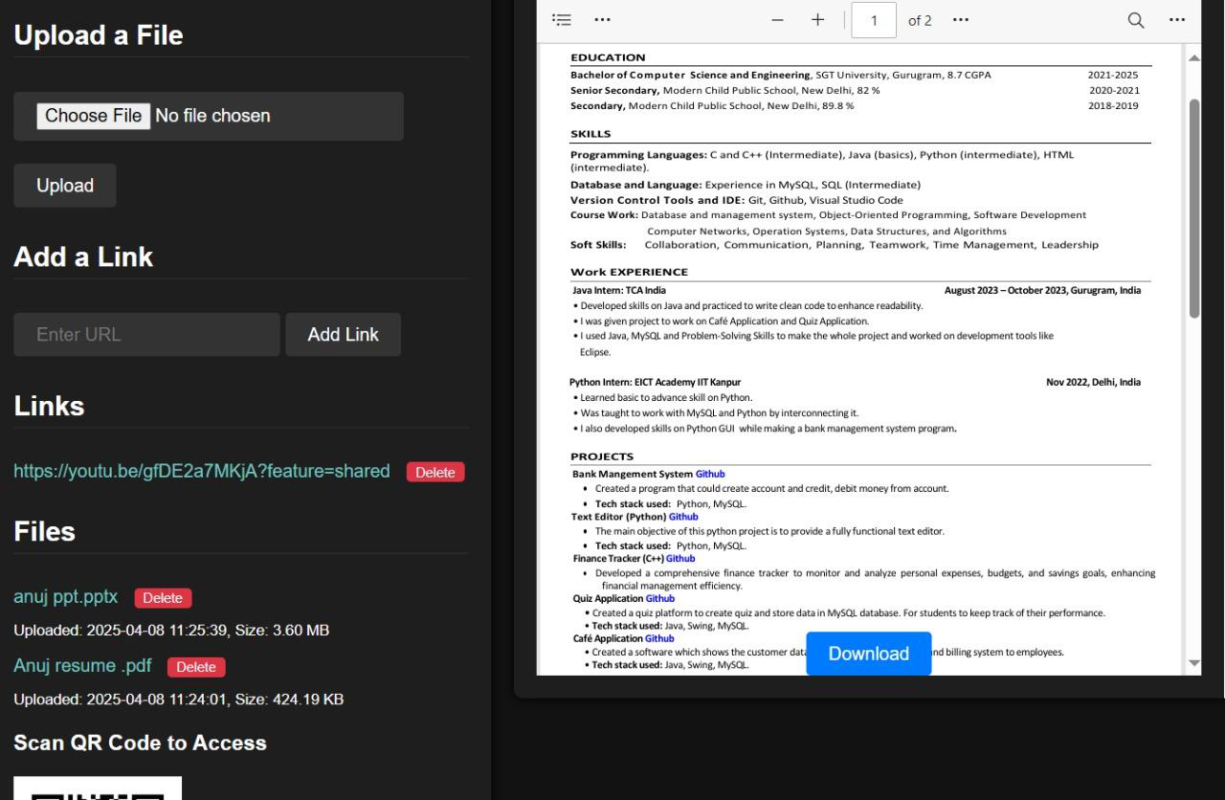

**Chapter 7: Conclusion**

**7.1 Project Summary**

The **Web-Based File and Link Management System** project was conceived and developed to address the increasing demand for an organized, secure, and user-friendly platform for managing digital files and external links. With the proliferation of digital content across industries and academic settings, the need for an efficient system that simplifies resource management while maintaining accessibility and security became apparent.

Throughout the project's life cycle, careful attention was given to both technical and functional aspects. Core functionalities such as file upload with instant previews, link submission with validation, QR code generation for mobile access, and simple download/copy mechanisms were successfully implemented. Furthermore, security measures like basic authentication and validation protocols ensured that the system maintained a robust and secure environment.

The project followed a modular and agile development methodology, allowing incremental progress, continuous testing, and iterative refinements. Using a technology stack comprising **Python Flask**, **HTML5**, **CSS3**, and libraries like **Highlight.js** and **pyqrcode**, a fully functional and scalable system was built that meets both current user needs and lays a strong foundation for future enhancements.

**7.2 Learning Outcomes**

The development of this project served as a significant bridge between academic learning and real-world application, offering invaluable experiences across multiple domains:

•**Application of Theoretical Knowledge:**   
Concepts learned through coursework such as web technologies, database management, backend frameworks, and security principles were applied in a hands-on manner, reinforcing academic understanding with practical exposure.

•**Technical Expertise Development:**   
Practical skills in full-stack development were greatly enhanced,   
including server-side programming with Flask, responsive UI design with HTML5 and CSS3, and integration of external libraries for added   
functionalities.

•**Problem-Solving and Analytical Thinking:**   
 Various challenges encountered during the project—from backend

connectivity issues to ensuring mobile responsiveness—sharpened problem-solving skills and promoted critical thinking.

•**Understanding of Software Development Lifecycle:**   
Working through requirement analysis, design, development, testing, and deployment phases provided a comprehensive understanding of how professional software projects are managed and delivered.

•**Professional Preparedness:**   
This project has contributed significantly to preparing for a career in software engineering by instilling not only technical knowledge but also best practices in documentation, version control, and user-centric development.

**7.3 Future Scope**

While the system achieves its initial goals effectively, there is ample scope for further enhancements to increase functionality, scalability, and security, including:

•Adding multi-user authentication with role-based access control.

•Integration with cloud storage solutions for better scalability.

•Advanced search, filtering, and categorization of uploaded content. •Implementation of encryption techniques for secure file and link sharing. •Automated testing and continuous integration pipelines for better maintainability.

These potential enhancements can evolve the system into a full-fledged, enterprise-level resource management solution.